Hartland Consolidated Schools - Chemical List and SDS
**RTD = Ready to Dispense**
**RTU = Ready to Use**

Product Name | Manufacturer | Manufacturer # | UOM |  | Application | SDS
Virex™ II 256 Germicidal Cleaner and Deodorant RTD™ 5L | Diversey | 3062768 | RTD | 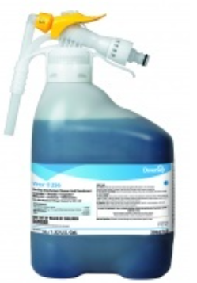 | Classroom Disinfectant, Kills MRSA and VRE. Meets bloodborne pathogen standards for decontaminating blood and body fluids.
Virex Tb Disinfectant Deodorizing Cleaner Spray | Diversey | 04743 | RTU | 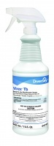 | Classroom Disinfectant, Kills MRSA and VRE. Meets bloodborne pathogen standards for decontaminating blood and body fluids.
Virex Plus One-Step Disinfectant Cleaner & Deodorant | Diversey | 101102925 | RTD | 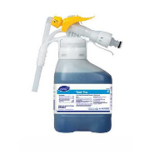 | Classroom Disinfectant, Kills MRSA and VRE. Meets bloodborne pathogen standards for decontaminating blood and body fluids.
Crew(TM) Restroom Floor & Surface Non-Acid Disinfectant Cleaner RTD™, | Diversey | 3063437 | RTD | 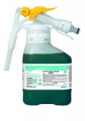 | Restroom Disinfectant & Bowl Care / Urinals
Crew Shower, Tub & Tile Cleaner | Diversey | 93063453 | RTD | 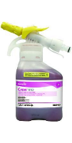 | Acidic shower room cleaner. Cleans soap scum, hard water deposits, rust, body oils, grease and dirt. Brightens stainless steel and ceramic tile
Crew Tile and Grout Rejuvenator | Diversey | 101104392 | RTU | 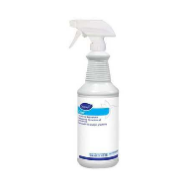 | Bleach-based cleaner for removing stains, whitening and brightening discolored grout.
Glance RTU Glass and Multi Surface Cleaner Spray Quarts | Diversey | 04705 | RTU | 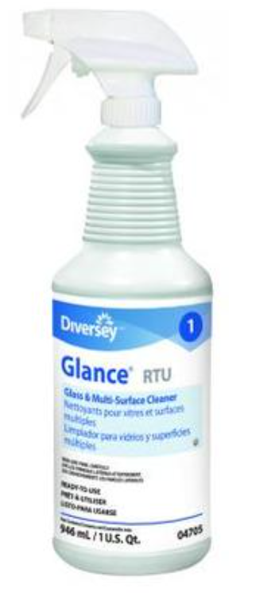 | Glass, Mirror, Window & Stainless-Steel Cleaner
Glance HC Glass & Multi-Surface Cleaner | Diversey | 93063402 | RTD | 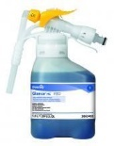 | Non-streaking, quick-drying, ammoniated glass cleaner. Cleans and shines glass, mirrors, sinks, countertops, stainless steel and many other washable surfaces.
GP Forward General-Purpose Cleaner | Diversey | 93145395 | RTD | 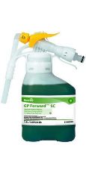 | Highly-versatile general cleaner concentrate that contains a blend of high-performance detergents to effectively clean surfaces. Excellent for use in scrub and recoat floor care programs.
PERdiem General Purpose Cleaner with Hydrogen Peroxide | Diversey | 94998859 | RTD | 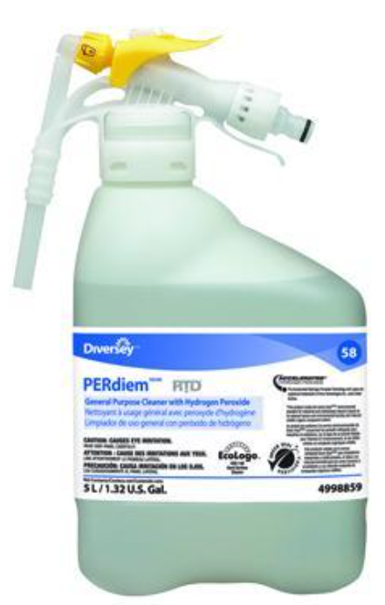 | Carpet extraction, Pre-spray and Spotting
Alpha-HP Multi-Surface Disinfectant Cleaner | Diversey | 5549254 | RTD | 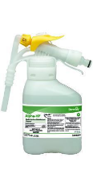 | An all-in-one, multi-purpose cleaner based on proprietary Accelerated Hydrogen Peroxide (AHP) technology.
Oxivir Five 16 Concentrate One Step Disinfectant Cleaner | Diversey | 4963357 | RTD | 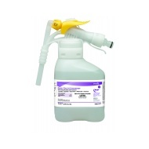 | Dilutable one-step disinfectant cleaner formulated with proprietary hydrogen peroxide technology. Effective against Human Immunodeficiency Virus, HIV-1 (AIDS Virus), Hepatitis B and Hepatitis C Virus (HBV and HCV), Pseudomonas aeruginosa, Staphylococcus aureus, Methicillin resistant Staphylococcus aureus (MRSA), Salmonella choleraesuis, Avian Influenza and VRE. Kills Norovirus and Canine Parvovirus.
Oxivir Tb Wipes | Diversey | 5388471 | RTU | 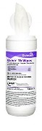 | Disinfects in 60 seconds. Virucide, bactericide, tuberculocidal, fungicide and non-food contact sanitizer. Kills MRSA and Norovirus. Meets bloodborne pathogen standards for decontaminating blood and body fluids.
Breakdown Enzyme Odor Eliminator | Diversey | 94291110 | 1 Gl. | 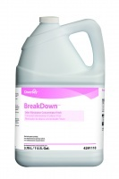 | Enzyme-producing bacteria odor eliminator. Contains enzyme-producing bacteria and odor counteractants that combat the source of odors. Versatile and effective against a wide range of odors in carpets, washrooms, trash cans and more.
RESTOROX One Step Disinfectant Cleaner & Deodorizer | Virox Technologies | 20105 | 1 Gl. | 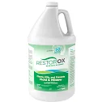 | Ideal for use in mold and mildew remediation. One-step disinfectant cleaner and deodorizer that kills 99.9% of germs with the power of AHP (Accelerated Hydrogen Peroxide).
Stride(TM) Citrus HC Neutral All Purpose Cleaner RTD™, | Diversey | 93063390 | RTD | 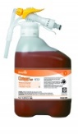 | Neutral Floor Cleaner & General-Purpose Cleaner
Spitfire SC Power Cleaner, 5L RTD | Diversey | 95892546 | RTD | 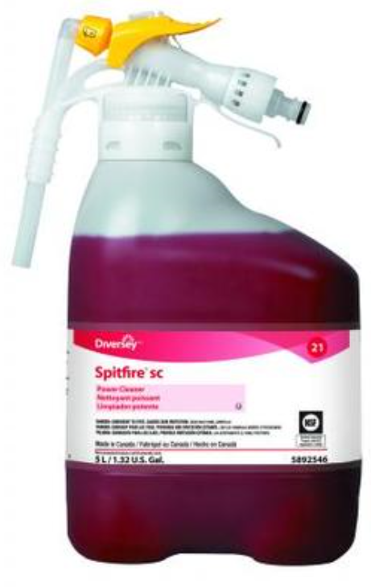 | Periodic Cleaner for dirt, grime and stains on a wide variety of surfaces.
Tempest SC Solvent Free Cleaner Degreaser | Diversey | 100986532 | RTD | 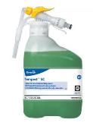 | A high-alkaline, solvent-free degreaser for industrial cleaning applications
Vectra High Performance Floor Finish | Diversey | 5105047 | Enviro Box (5 Gl.) | 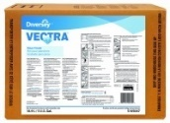 | Floor Finish – Diamond-like brilliance, clarity and long-lasting performance
Carefree Matte Low Gloss Floor Finish | Diversey | 5104757 | Enviro Box (5 Gl.) | 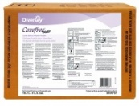 | A versatile high performance floor finish without the high gloss.
Bravo Heavy Duty Low Odor Stripper | Diversey | 95115958 | Enviro Box (5 Gl.) | 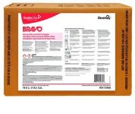 | Low-odor, heavy duty stripper for today's tough build-ups and burnished finishes. Excels with superior wetting, penetration and emulsification properties.
Pro Strip SC High Efficiency Floor Stripper | Diversey | 95547312 | RTD | 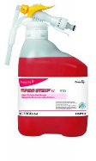 | A powerful stripper that quickly bites through layers of floor finish, decreasing downtime and labor costs, while reducing the odors associated with floor stripping. This highly concentrated low odor floor stripper is not formulated with ammonia or butyl.
Deep Gloss Maintainer for Stainless Steel | Diversey | 94970590 | RTU - Aerosol | 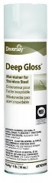 | Cleans and protects stainless steel and other hard surfaces such as copper, brass and aluminum. Resists finger marks, smudges and water marks.
Shine-Up Lemon Furniture Polish | Diversey | 9576557 | RTU - Aerosol | 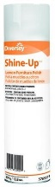 | Cleans and polishes furniture to a beautiful shine. Resists smears and fingerprints.
Emerel Creme Cleanser | Diversey | 94995295 | RTU - Quart | 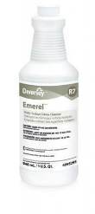 | Mild acid formula that quickly removes hard water deposits, grease, soap scum, scuff marks and other stubborn spots and build-up without scratching the surface.
Crystal Dry Extra Carpet Cleaner | R.E. Whittaker Company | CDX-2 | 12 oz. | 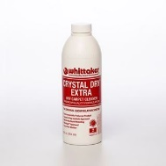 | CRYSTAL DRY EXTRA cleaning agent combines unique crystallizing polymers with effective detergent components, creating a perfect blend to emulsify embedded soils (both dry and oily) and encapsulate them for vacuum recovery
Snapback Spray Buff | Diversey | 904116 | 1 GL | 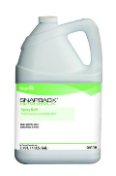 | For conventional maintenance systems. Gives you that "just-finished" shine. Keeps your floors looking their best at all times
KAIBLOOEY Low-Foam Restroom Cleaner | Kaivac Inc. | KBLOOEYK | 1 GL | 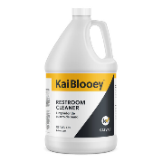 | Kaivac Use - KaiBlooey is a high-performance restroom cleaner that contains a blend of fast-acting mild acids to de-scale mineral deposits and remove soap scum.
KaiDri Rinse Aid | Kaivac Inc. | KDRIQ |  | 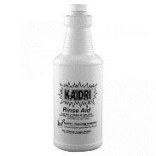 | Kaivac Use - KaiDri helps water sheet off hard surfaces to wipe out hard water spots before they get started. It also reduces the size of the water droplets, speeding up the drying process.
Carpet Shampoo | Diversey | 95002689 | 1 GL | 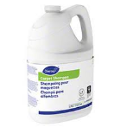 | Emulsifies soils and wicks to the carpet's surface. Works with rotary and dry-foam cleaning processes. Leaves no tacky residue. Safe on all carpets, including wool.
Extraction Rinse | Diversey | 903730 | 1 GL | 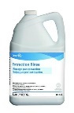 | Flushes out and removes detergent residues that cause re-soiling. Safe on all types of carpets, including wool.
Defoamer | Diversey | 95002620 | 1 Qt. | 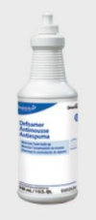 | Carpet Extraction - Eliminates frequent emptying of foam-filled recovery tanks.
Concept "915" Ice Melt Remover | Stearns Packaging Corporation | ST-717 | Case | 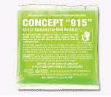 | Ice Melt Remover – Removes the white crust of ice melting compound residue
Clothesline Fresh Laundry Detergent | Spartan Chemical Company | 7003 | 1 GL | 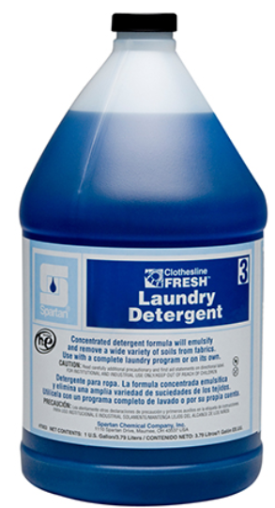 | Quickly suspends tough oily and particulate soils to prevent them from redepositing back onto the fabric.

